Program of Studies
Career Pathways

VICKSBURG

HIGH SCHOOL

2022-2023

VICKSBURG HIGH SCHOOL
501 E. HIGHWAY
VICKSBURG, MICHIGAN 49097
(269) 321-1100
FAX (269) 321-1155

Graduation Requirements.......................................................... 3
Career Pathways...................................................................... 4-6
Arts and Communication; Business, Management, Marketing and Technology; Engineering/Manufacturing and Industrial Technology; Health Sciences; Human Services; Natural Resources and Agriscience
Course Descriptions............................................................. 7-27

Applied Technologies, Business, English, Fine Arts, Life Skills, Mathematics, Physical Education, Science, Social Studies/History, World Languages, Miscellaneous
EFA and CTE Course Schedules & Description............... 28-42

CONTENTS

VICKSBURG HIGH SCHOOL ADMINISTRATION

Adam Brush - Principal
Matthew Hawkins- Assistant Principal
Michael Roy – Athletic Director

VICKSBURG HIGH SCHOOL COUNSELORS

Andrew Lothschutz
Jessica Peck

GRIEVANCE PROCEDURES FOR NONDISCRIMINATION AND EQUAL OPPORTUNITY /ACCESS

Any person who believes that s/he has been discriminated against or denied equal opportunity or access to programs or services may file a complaint, which shall be referred to as a grievance, with the District’s Civil Rights Compliance Officers,

Steve Goss | Christine Veld
Assistant Superintendent | HR Coordinator
269-321-1000 | 269-321-1018
301 S. Kalamazoo St. | 301 S. Kalamazoo St.
Vicksburg, MI 49097 | Vicksburg, MI 49097

The individual may also, at any time, contact the U.S. Department of Education, Office of Civil Rights, 600 Superior Avenue, Room 750, Cleveland, OH 44114-2611.

Michigan Merit Curriculum
High School Graduation Requirements
Subject Area | Description | Personal Curriculum  (Modifications)
English  Language Arts  4 Credits | - Aligned with subject area content expectations developed by the Department and approved by the State Board of Education | - No modifications except for students with an IEP
Mathematics  4 Credits | - Algebra 1  - Geometry  - Algebra 2 (algebra 2 may be taken over a 2 yr. Period for 2 credits or 1.5 yrs for 1.5 credits)  - Algebra 2 can be substituted with a CTE program if the student successfully completes the tested content  - 1 additional math or math related credit or a course in financial literacy  - 1 math or math related credit must be taken in the last year of high school | - Complete at least 3.5 math or math related credits  - Complete a math or math related credit in the final 2 years  OR  - Complete a two year Career and Technical Education curriculum, which includes Algebra 2 content as assessed on State assessments  OR  - Completes 1 semester of statistics or technical math
Science  3 Credits | - Biology  - Chemistry, Physics, Anatomy or agricultural science  - 1 additional credit that covers same content as Chemistry or Physics benchmarks  - Additional credit can be a CTE program in MDE approved Computer Science or other CTE program (regardless of content) | - No modifications except for students with an IEP
Social Studies  3 Credits | - .5 Civics  - .5 Economics  - U.S. History and Geography  - World History and Geography | - No modification to Civics  - 2 credits must be earned  - Modified only if the student takes an additional credit beyond the required credits in English Language Arts, Math, Science, or World Languages  OR  - Completes a CTE program
Health and Physical Education  1 Credit | - 1 Credit developed by the Michigan Department of Education  OR  - .5 credit in health and .5 credit in an extracurricular activity that involves physical activity | - Modification only if student takes additional credit(s) beyond the required credits in English Language Arts, Math, Science, or World Languages  OR  - Completes a CTE Program
Visual, Performing, Applied Arts  1 Credit | - Credit guidelines developed by the Michigan Department of Education | - Modification only if student takes additional credit(s) beyond the required credits in English Language Arts, Math, Science, or World Languages  OR  - Completes a CTE Program
World Language  2 Credits | - Credits are earned in grades K-12 (course content must be age appropriate- not H.S. equivalent)  OR  - An equivalent learning experience in grades K-12  - Pupils may substitute 1 credit in CTE or Visual Performing Arts | - No modifications
Online Learning Experience | Online course or learning experience  OR  Online experience is incorporated into each of the required credits | - No modifications
NOTES: Every class will need a MINIMUM of 24 total credits in order to graduate from Vicksburg High School. Additional restrictions may apply to CTE programs, Personal Curriculums and Special Education students.
VICKSBURG HIGH SCHOOL

CAREER PATHWAYS

ARTS AND COMMUNICATION PATHWAY

The Arts and Communication Pathway includes careers related to the humanities and to the performing, visual, literary and media arts.

Characteristics of this pathway include:
- Creative thinkers
- Individuals who are imaginative, innovative and original
- Individuals who like to communicate ideas
Interests and abilities typical of this pathway include:
- Strong communication and interpersonal skills
- A special talent in performing (acting, singing, or dancing)
- The ability to write or draw creatively

Careers in this pathway may include: Specific examples include:
Creative or Technical Writing Artists
Illustrating Journalists
Graphic Designing Industrial Designers
Publishing Musicians
Theater Arts Photographers
Journalism Theater Technicians
Languages
Radio and Television Broadcasting
Photography
Advertising
Public Relations

BUSINESS, MANAGEMENT, MARKETING AND TECHNOLOGY PATHWAY
The Business, Management, Marketing and Technology Pathway includes careers related to all aspects of business including accounting, business administration, finance, information processing, and marketing.

Characteristics of this pathway:
- Work that involves convincing others of your point of view
- Work with ideas, products and people
- Working with computer technology
- Working in a competitive work environment
- Work which is structured with clear guidelines
- Working indoors
- Planning and directing the activities of an organization
Interests and abilities typical of this pathway:
- Strong communication and interpersonal skills
- The ability to think logically and make decisions
- The desire to perform detail work with numbers or words
- The ability to meet and talk with new acquaintances
- The ability to inspire customer confidence

Careers in this pathway may include: Specific examples include:
Entrepreneurship Accountants
Sales Business Managers
Marketing Salespersons
Hospitality and Tourism Buyers
Computer/Information Systems Computer Network
Finance Administrators
Accounting Secretaries
Office Administration Stock Analysis
Personnel Economics Management
ENGINEERING, MANUFACTURING AND INDUSTRIAL
TECHNOLOGY PATHWAY

The Engineering, Manufacturing and Industrial Technology Pathway includes careers related to the technologies necessary to design, develop, install, or maintain physical systems.

Characteristics of this pathway include:
- Figuring out how things work
- Building things
- Working with your hands
Interests and abilities typical of this pathway include:
- The ability to use tools to properly gather data
- The ability to understand and interpret data
- The ability to think independently to solve problems and draw conclusions
- The ability to read and understand technical information

Careers in this pathway may include: Specific examples include:
Designing Architects
Engineering and Science Airplane Pilots
Service Technicians Engineers
Manufacturing Technology Carpenters
Transportation Microcomputer Specialists
Construction Equipment Operators
Technicians
Mechanics

HEALTH SCIENCES PATHWAY

The Health Sciences Pathway includes careers related to the promotion of health, as well as, the treatment of injuries, conditions, and disease.

Characteristics of this pathway include:
- Helping people when they are sick
- Learning about diseases and how the body works
Interests and abilities typical of this pathway include:
- An interest in the science field
- The ability to make decisions
- The ability to work under stress
- Flexibility, willingness to change
- Patience and understanding
- Self-discipline
- The desire to serve or help other people
- The willingness to work as part of a team

Careers in this pathway may include: Specific examples include:
Medicine Physicians
Dentistry Nurses
Nursing Pharmacists
Therapy and Rehabilitation Health Facility
Nutrition Administrators
Fitness and Hygiene Dental Assistants
Public Health Medical Technicians Physical Therapists

HUMAN SERVICES PATHWAY

The Human Services Pathway includes careers in child care, civil service, education, hospitality, and the social services.

Characteristics of this pathway include:
- Working directly with people or groups of people
- Working with people to help solve problems
- Making things better for other people
Interests and abilities typical of this pathway include:
- The ability to lead and/or influence others
- The ability to work under stress
- Enthusiasm
- Flexibility
- Patience and understanding
- Self-discipline
- The ability to speak and write well
- The desire to serve or help other people
- The willingness to work as part of a team

Careers in this pathway may include: Specific examples include:

Law and Legal Studies Postal Workers
Law Enforcement Police Officers
Public Administration Lawyers
Child and Family Services Teachers
Social Services Counselors
Public and Private Education School Administrators
Fire Fighters
Clergy
Social Workers

NATURAL RESOURCES AND AGRISCIENCE PATHWAY

The Natural Resources and Agriscience Pathway includes careers related to natural resources, agriculture and the environment.

Characteristics of this pathway include:
- Working outdoors with plants and/or animals
- Improving the environment
- Studying wildlife
Interests and abilities typical of this pathway include:
- The ability to use tools to properly gather data
- The ability to understand and interpret data
- The ability to think independently to solve problems and draw conclusions
- The ability to read and understand technical information

Careers in this pathway may include: Specific examples include:

Agriculture Environmentalists
Earth Sciences Turf Grass Managers
Environmental Sciences Farmers
Fisheries Management Landscape Architects
Forestry Plant Scientists

Horticulture Marine Biologists
Wildlife Management Agricultural Equipment
Veterinary Science Mechanics
Conservation Officer
Meteorologist
Forester
Veterinarians
AP Capstone Program Description
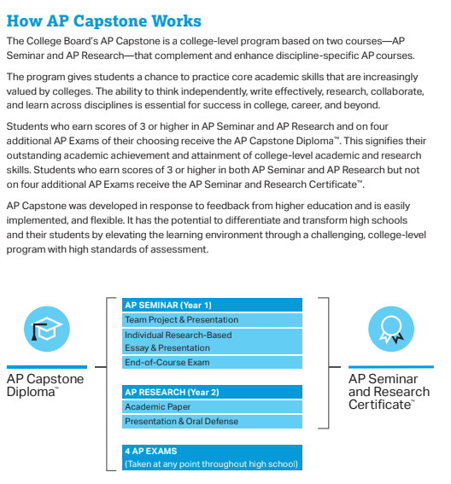

Course Descriptions:
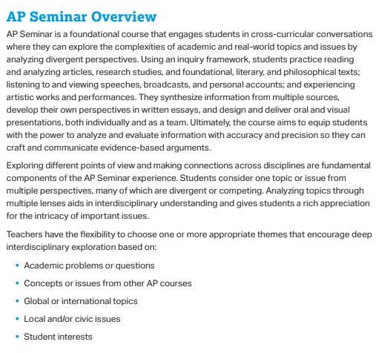

AP Research Overview
Prerequisite: AP Seminar is a prerequisite for AP Research. Preference will be given to students who have passed the AP Seminar Exam.
AP Research allows students to deeply explore an academic topic, problem, or issue of individual interest. Through this exploration, students design, plan, and conduct a yearlong investigation to address a research question.

In the AP research course, students further develop the skills acquired in the AP Seminar course by learning research methodology, employing ethical research practices, and accessing, analyzing, and synthesizing information. Students reflect on their skill development, document their processes, and curate the artifacts of their scholarly work through a process and reflection portfolio.
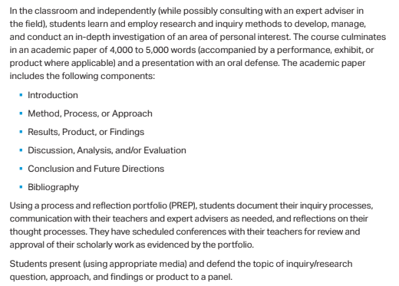

APPLIED TECHNOLOGIES

Computerized Manufacturing I (CTE) Grade Level: 9, 10, 11, 12 1 or 2 Credits
This exciting, fast-paced pre-engineering course provides advanced technology training in computer-aided design and computer manufacturing systems. All equipment is state of the art including Haas and Mazak CNC machining centers. The course uses CAD software including Solidworks, Mastercam and Keycreator. It also features demonstrations and maximizes student laboratory work (80% hands-on). Students gain planning, organizing and decision-making skills while also developing acceptable attitude, interpersonal and equipment-related skills. Paid co-op opportunities are available to second-year students who are placed at local manufacturers. Computerized Manufacturing prepares students for immediate employment, advanced schooling and/or apprenticeship opportunities with local area employers. Students may take this course for two years.
*Potential for articulated credits with Kalamazoo Valley Community College
*4th Related Math and Visual Performing & Applied Arts Credit.
*See your counselor for possible 3rd Science and/or 2nd World Language Credit
*This is an Early/Middle College eligible program

Computerized Manufacturing II (CTE) Grade Level: 10, 11, 12 1 or 2 Credits
Continuation of Computerized Manufacturing I. Stressing safety and advanced machining practices on larger, more complex projects. Complex fixtures, jigs and cutting tools, designed for production manufacturing will be produced. The student will study simple SPC and more advanced inspection methods, design and manufacturing of molds, dies, and other selected tool making projects. Additionally there will be exposure to CAD/CAM programming leading to CNC milling, and turning. This course may be taken for 2 years.
*Potential for articulated credits with Kalamazoo Valley Community College
*Visual and Performing Arts and 4th Related Math Credit.
*See your counselor for possible 3rd Science and/or 2nd World Language Credit
*This is an Early/Middle College eligible program
Prerequisite: Computerized Manufacturing I

Mechatronics Engineering (CTE) Grade Level: 9, 10, 11, 12 1 Credit
Electronics and mechanical components work together to make up complex systems from a car to a robot to automation lines. Mechatronics students learn to design, build, program, and troubleshoot electro-mechanical systems using the principles of mechanics, electronics and computer science. Students learn about electronics, robotics, equipment controls and sensors, programming, hydraulics/pneumatics, CAD/CAM, basic machining, and CNC.
*Potential for articulated credits with Baker College
*2nd World Language Credit
*3rd Science Credit
*4th Related Math Credit
Visual Performing & Applied Arts Credit
Prerequisite: None

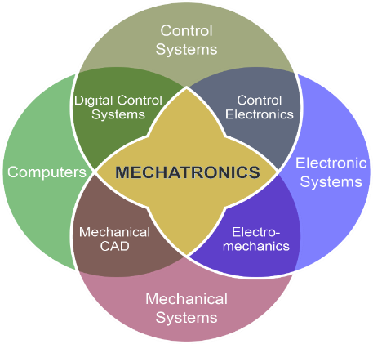
BUSINESS

School Store Operations Grade Levels: 9, 10, 11, 12 1 Credit
Students are responsible for operation of the school store during all three lunches, including maintaining the school vending machines. Topics include: point-of-sale system operation, accounting for the school store, supervising store operations, customer relations, development of leadership qualities, and development of a work ethic for success in business. The class must be taken for a full semester (18 weeks); but, can be taken for the whole year. There is no homework for this class, but you must make up work for any days missed.
Prerequisite: Enrollment in or completion of a previous Business class preferred or teacher approval.

Accounting I (CTE) Grade Level: 9, 10, 11, 12 1 Credit

An introduction to double-entry accounting. Topics include analyzing and recording transactions into a variety of journals, posting to general and subsidiary ledgers, the 8 column worksheet, and the financial statement. Writing will include answering questions about reading. Both manual and automated accounting will be learned. This class must be taken for a full semester (18 weeks). There will be 0 - 2 hours of homework per week. Potential for articulation credits with Baker College, Davenport University, and Kalamazoo Valley Community College.
*4th Related Math. *See your counselor for possible 3rd Science and/or 2nd World Language Credit. *This is an Early/Middle College eligible program

Accounting II (CTE) Grade Level: 10, 11, 12 1 Credit
This course is very much like Accounting I, with the exception that the class is much more self-paced. The students work in a setting more like a lab, where instruction and learning are individualized. Topics include departmental accounting, depreciation, bad debts, accruals, corporate accounting, and development of effective work habits. Writing will include questions and terms from books, accounting problems from textbooks, and accounting simulations. Reading will be assigned from the textbook. This class must be taken for a full semester (18 weeks). There will be 0 - 3 hours of homework per week depending on how much the student gets done during class time.
*4th Related Math. *See your counselor for possible 3rd Science and/or 2nd World Language Credit. *This is an Early/Middle College eligible program
Prerequisite: Accounting or equivalent.

Marketing (CTE) Grade Level: 9, 10, 11, 12 1 Credit
Basic job skills and attitudes for success in the business world will be the focus of this course. Topics include sales, promotion, advertising and DECA (Distributive Education Clubs of America). Writing will include questions and terms from book, workbook pages, and essay questions on tests. Reading will be assigned from the textbook. This class must be taken for a full semester (18 weeks). There will be 0-2 hours of homework per week. Potential for articulated credits with Baker College, Davenport University, and Kalamazoo Valley Community College. *4th Related Math and visual performing or applied art. *See your counselor for possible 3rd Science and/or 2nd World Language Credit. This is an Early Middle College eligible program.

AP Computer Science Principles (CTE) Grade Level: 9, 10, 11, 12 1 Credit
AP Computer Science Principles is an introductory college-level computing course. Students cultivate their understanding of computer science through working with data, collaborating to solve problems, and developing computer programs as they explore concepts like creativity, abstraction, data and information, algorithms, programming, the internet, and the global impact of computing. *4th Related Math and visual, performing or applied art.

ENGLISH

English 1 Grade Level: 9 1 Credit
English 1 is a study of reading, writing, listening, and speaking skills. Writing instruction focuses on some strong building blocks of writing including effective thesis statements, strong topic sentences, sound support, and basic grammatical structures. Reading is varied and is assigned from short stories, non-fiction pieces, poetry, and drama. Students can expect three to five hours of homework per week.
Prerequisite: None

English 2 Grade Level: 10 1 Credit
English 2 is a continuation of English 1, presenting study of reading, writing, listening and speaking skills related to current issues. Topics include making connections between literature and real life situations, thematic units on decision making, leadership, perceptions and family matters. Writing will include essays, including informative and creative writing. Reading will be assigned from drama, short stories, essays, news articles, and poetry. There will be an average of three to five hours of homework per week. Many classroom assignments will model Michigan Merit Exam (MME) test questions, which include timed writing and test taking strategies.
Prerequisite: Credit earned in English 1

English 3 Grade Level: 11 1 Credit
English 3 is an extension of English 2 where the focus will be writing, reading, speaking, and listening. Topics include persuasive writing; themes include individual and society and responsibility as a citizen. Expressive, informative, persuasive and creative writing will be included. Reading will be assigned from drama, poetry, short stories, essays, and articles. There will be three to five hours of homework per week. Many classroom assignments will model Michigan Merit Exam (MME) test questions, which include timed writing and test taking strategies.
Prerequisite: Credit earned in English 2

English 4 Grade Level: 12 1 Credit
A course designed to polish reading, writing, speaking and listening skills. Thematic units include Existentialism, Passion vs. Reason, Appearance vs. Reality, Madness vs. Sanity, Justice, Innocence vs. Experience, Compassion, Civic Responsibility, and Satire. Writing may include journals, essays, poetry, research, short stories. Reading will be assigned from novels, short stories, plays, poetry, magazine and newspaper articles. There will be 5 hours of homework per week.
Prerequisite: Credit earned in English 3

AP English Language and Composition Grade Level: 11, 12 1 Credit
An extensive study of writing and rhetorical analysis (comparable to an entry-level college composition course). Topics include writing for a variety of purposes and audiences, time essay writing and AP test taking strategies and in-depth evaluations of rhetorical styles and strategies. Writing will include weekly essays and an extensive writing portfolio. There will be 8 hours of homework per week.
A Summer Reading Assignment and Essay are required.

AP English Lit & Composition Grade Level: 11, 12 1 Credit
This full year offering is an extensive study of writing and literary analysis (comparable to an entry-level college English literature course). Topics include careful reading and critical analysis of a variety of literary works as well as AP Test taking strategies. Analysis will focus on structure, style, themes, figurative language, symbolism, and tone. Writing will include frequent essays and timed writings. Reading will be assigned from 5-7 major literary works (epics, novels, plays, etc.) per semester. There will be 8 hours of homework per week.
A Summer Reading Assignment and Summer Essay are required.

FINE ARTS

Art I Grade Level: 9, 10, 11, 12 .5 Credit
This is an introductory-level art class where students do a wide variety of hands-on projects. Students will study various techniques and create finished projects using the following mediums: graphite, color pencil, oil pastel, printmaking, paint and clay. Students will also focus on learning and effectively incorporating the elements and principles of art, the history of art, and art criticism into their artwork and daily routine. Art I provides students with a sound foundation in relation to technique, composition, and art history which they can build upon in advanced art courses offered at VHS.

2-D Drawing Grade Level: 9, 10, 11, 12 .5 Credit
This is an advanced-level art class where students will refine their art production skills. Students taking this course will read and write about the work of various artists and apply what they learn to their own work. They will self-evaluate and make personal judgments about their work and the work of others. They will mat and display their work for viewing. Students will use direct observation and personal expression to create their works of art. Graphite, charcoal, colored pencil, scratchboard, pastels, and printmaking are the mediums explored in this course.
Prerequisite: none

2-D Printmaking Grade Level: 9, 10, 11, 12 .5 Credit
This is an advanced-level art class where students will refine their art production skills. Students taking this course will read and write about the work of various artists and apply what they learn to their own work. They will self-evaluate and make personal judgments about their work and the work of others. They will mat and display their work for viewing. Students will learn various printmaking techniques including monotypes, collographs, relief printing, silk screening, and various intaglio processes. In addition, some fiber arts and drawing projects will be included.
Prerequisite: none

2-D Painting Grade Level: 9, 10, 11, 12 .5 Credit
This is an advanced-level art class where students will refine their art production skills. Students taking this course will read and write about the work of various artists and apply what they learn to their own work. They will self-evaluate and make personal judgments about their work and the work of others. They will mat and display their work for viewing. Students will study a variety of painting styles and techniques using watercolor, acrylics, oil, tempera, gouache, and mixed media.
Prerequisite: none

3-D Sculpture Grade Level: 9, 10, 11, 12 .5 Credit
This is an advanced-level class that explores different sculptural techniques using different media through hands-on experience, reading, and written assignments. You will use clay, wire, wood, metal, found objects, and stone to create works of art in a wide range of subject matter. In addition, other multimedia and drawing based work will be included. The focus will be on improving your sculpture skills and increasing your knowledge of private, public, and monumental sculptures and the artists that create them. Class participation is a requirement. A cooperative sculpture project may be planned for the class.
Prerequisite: none

Advanced Placement Art - Drawing Grade Level: 11, 12 (Full Year) 1 Credit
This course is designed for the serious art student who has taken an appropriate selection of art classes prior to enrolling. The class will emphasize high quality work with product orientation. Students will complete in class assignments as well as develop a body of work unique to them in a concentrated portfolio. Extensive work outside the classroom is required. The end product for students will be a portfolio which will be submitted for evaluation by the art teacher and guidance counselor. This course is designed to assist students in the preparation of that portfolio.
Prerequisite: Must have Art I and 2-D Drawing, OR portfolio review and teacher approval before enrolling in this class.

Photography I Grade Level: 9, 10, 11, 12 .5 Credit
Students will learn how to express themselves by integrating artistic and technical aspects of black and white photography. Hands-on activities will be the focus of this course. Students will learn about the aperture/shutter principles, B&W film processing, 35 mm camera techniques, darkroom techniques, and digital editing software techniques. Students will learn about the history of photography and the various styles of famous photographers. Students will also keep a portfolio and be expected to take pictures during and outside of class.
Prerequisite: None

Photography II Grade Level: 10, 11, 12 .5 Credit
Students who have completed Photography I would be able to build upon their skills and portfolio in Photography II. Students will learn about advanced black and white techniques along with advanced digital editing techniques when working in the digital format. Color theory (B&W contrast filters), advanced processing techniques and advanced darkroom techniques (Sabatier effect) are a few units that students would be introduced to during Photography II. Students will be asked to take pictures during and outside of class time. Students will also keep and maintain a digital portfolio throughout the semester.
Prerequisite: Photography I

Film & Video Arts Grade Level: 9, 10, 11, 12 .5 Credit/sem
(1-hour or 2-hour class full year/semester) 1 Credit/year
EFA Intro to Film & Video teaches the fun skills of filming, editing, directing, producing and scriptwriting for film and video. Students receive in-depth training on professional filmmaking and work on projects such as music videos, short comedies, commercials, action movies and more. Students will enter several film contests to receive awards, and take field trips to watch movies in the theater. Students will work on group videos during class and work on individual projects outside of class. Students taking two hours will have more time to edit and work on personal projects. No experience necessary.
Prerequisite: none

Advanced Video Arts Studio Grade Level: 9, 10, 11, 12 .5 Credit/sem
(Full year or semester) 1 Credit/year
This is a project-based film, animation and special effects class for students 9th-12th that have already taken at least one semester of a video or TV production class. The class will concentrate on individual student films that will be used for portfolio work and entered into video competitions. Students will learn about lighting, sound, directing, special effects, and advanced filming and editing techniques. Students can also work on animation, documentaries or other projects. The class can be taken repeatedly and by semester or full year.
Prerequisite: One semester of Video Arts or TV Production

Treble Chorus Grade Level: 9, 10, 11, 12 .5 Credit
Treble Chorus is a select group of motivated students of 9th through 12th grades. This group focuses on performing advanced music from a variety of genres and reading music at an advanced level. We will sing, study music theory and composition, listen to and evaluate musical performances and discuss music’s place in history and culture. Members of Treble Chorus will participate in after school rehearsals and events. Enrolling in Treble Chorus represents a year-long commitment.
Prerequisite: Audition with instructor.

Chorale Grade Level: 9, 10, 11, 12 .5 Credit
Chorale is a group of male and female singers of grades 9 through 12. This ensemble is dedicated to singing a wide variety of choral music, including music from different historical periods, different popular genres, Broadway musicals and African-American spirituals. We will focus on developing our choral singing technique and improving our ability to read music. We will learn musical vocabulary, sing, compose, listen to and evaluate musical performances and discuss music's role in history and culture. Students will participate in required after school rehearsals and performances. Students may register for one semester or a full year.
Prerequisite: Audition with instructor.

Chamber Singers Grade Level: 9, 10, 11, 12 .5 Credit
Chamber Singers is an elite group of motivated and responsible young men and women of 10th through 12th grades, though exceptions may be granted for 9th graders in some cases. Chamber Singers members are dedicated to learning and performing a wide variety of advanced choral music. Membership in Chamber Singers requires participation in after school events and rehearsals. We will sing, develop advanced music-reading skills, study music theory, listen to and evaluate musical performances and discuss music’s place in history and culture. Enrolling in Chamber Singers represents a full year commitment.
Prerequisite: Audition with instructor.

Early Dawgs Jazz Band Grade Level: 9, 10, 11, 12 .5 Credit
The VHS Jazz ensemble is open to all students who are able to play on a jazz instrument; saxophone, trombone, trumpet, piano, guitar, bass and drum set. Jazz Band is a full year long course devoted to the performance of jazz literature. Students will study and perform swing, be-bop, Latin, funk and rock jazz. The class meets 6:30-7:20 a.m. on selected days. The Jazz Ensemble will perform at VHS band concerts and jazz festivals throughout Michigan and nationally.

Top Dawgs Jazz Band Grade Level: 9, 10, 11, 12 1 Credit
The VHS Top Dawgs Jazz ensemble is open to all students. Jazz Band is a full year long course devoted to the performance of jazz literature and is the top performing jazz ensemble at VHS. Students will study and perform swing, be-bop, Latin, funk and rock jazz as well as explore more in-depth jazz theory. Students must be able to play on a jazz instrument; saxophone, trombone, trumpet, piano, guitar, bass and drum set. The class meets daily. The Jazz Ensemble will perform at VHS band concerts, and perform at Jazz Festivals throughout Michigan and nationally.

Marching Band (1st semester) Grade Level: 9, 10, 11, 12 .5 Credit
The ensemble is open to all students who participate in the band program. The Big Red Machine consists of brass, woodwind, percussion, and a flag corps. Students are required to attend band camp in August, as well as participate in summer rehearsals. The Big Red Machine performs at home football games, parades, and marching band competitions in the West Michigan Area. Memorization of music and drill is also required. The ensemble changes over to Symphonic Band at the conclusion of the marching season.

Concert & Symphonic Band (2nd semester) Grade Level: 9, 10, 11, 12 .5 Credit
Open to all band students in the music program. The concert and symphonic bands perform a variety of literature throughout the winter and spring and will attend festivals in Michigan and nationally. Students will be exposed to baroque, classical, and modern concert band music. Students will be exposed to scales and rhythms and will require playing assessments to determine ensemble placement. Students will perform multiple concerts during the semester. All concerts are required.

Wind Ensemble Grade Level: 9, 10, 11, 12 1 Credit
Wind Ensemble is accessible by audition only. The wind ensemble is the top concert ensemble at VHS. Students who participate in the group will be challenged with a variety of band literature, including modern, classical, romantic, and baroque. The band will perform both in school and at band festivals throughout Michigan and nationally. The ensemble is dedicated to the excellence in performance of band literature. All wind ensemble students will be encouraged to perform at Solo & Ensemble Festival. Private lessons will be highly suggested.
LIFE SKILLS

Nutrition Grade Level: 9, 10, 11, 12 .5 Credit
Nutrition Education assists students in considering the complexity of their environment in making choices about diet and behavior. Topics include the food pyramid, vitamins, minerals, exercise, weight management, fad and balanced diets, nutrition careers, foreign food, food selection, and basic food prep. Writing will include classroom assignments and research. Reading will be assigned for the text and current media. There will be approximately 1 hour of homework per week.
Prerequisite: None.

Family Living/Child Development Grade Level: 10, 11, 12 .5 Credit/sem
(Full year or semester) 1 Credit/year
A study of the unique and common characteristics we find in the families of this decade. Emphasis in family relations and parenting skills. Topics include family issues, the family life cycle, relationships, marriage, pregnancy, labor and delivery, child care, and child development. Reading will be assigned from the text and current media. There will be 1 - 2 hours of homework per week. Community Service (3 hrs) and “Baby Think It Over” infant simulators are required for successful completion of the course.

Personal Finance-Family and Consumer Science Grade Level: 12 1 Credit
Personal Finance is a two-semester, one credit course that helps students to develop skills in managing their personal finances today and in the future. Areas of study include the acquisition of information, skills and strategies to get, earn, grow, stretch, keep, invest and protect money. Decision-making to consider wants vs. needs, goals (short and long term) and the application of knowledge will be incorporated. Topics include basic consumer economics, financial planning, career exploration, developing a financial plan, savings, investing, credit, gambling, consumer fraud, identity theft and insurance. Personal planning and cost related evaluations will be explored for major life cycle events; buying a car, paying for college, renting an apartment, living on your own, health care, designing a vacation plan, buying a home, parenting, divorce, aging and funerals. This class counts as a 4th related math credit.
Prerequisite: None

MATHEMATICS

*Technology recommendations: TI graphing calculators (83, 84+) strongly recommended for all math courses. A TI-83+ would be best for any new purchase.

Algebra I Grade Level: 9 1 Credit
An introduction to the discipline of algebra. Topics include statistics and linear algebra with applications to “real life” situations. There will be 2-3 hours of homework per week. Writing will include explaining math procedures and concepts on assignments or journals.
Prerequisite: None

Geometry Grade Level: 9, 10 1 Credit
A study of the mathematical properties of space. Topics include geometric art, circles, reasoning, construction, area, volume, congruence, similarity, and trigonometry. Writing will include notes, terminology, and a conjecture list. There will be 2-3 hours of homework per week.
Prerequisite: Successful completion of Algebra I.

Algebra II Grade Level: 10, 11, 12 1 Credit
A bridge to higher math. Challenging. Topics include exponents, logarithms, variation equations, series and sequences, and trigonometry. There will be 2-3 hours of homework per week. An A.E. is recommended. Writing will include data descriptions and explaining math procedures on assignments or journals.
Prerequisite: Successful completion of both Algebra I and Geometry.

Advanced Geometry Grade Level: 9 1 Credit
A study of the mathematical properties of space through a proof-oriented approach. Topics include proof, circles, area, volume, congruence, similarity, trigonometry, and algebra connections. Writing will include notes, terminology, and formal proofs. There will be 2-3 hours of homework per week.
Prerequisite: Successful completion of Algebra I in 8th grade or teacher recommendation.

Advanced Algebra II Grade Level: 10 1 Credit
An accelerated extension of Algebra. Topics include linear modeling, systems of equations, quadratic equations, exponential equations, rational equations, etc. Writing will include explaining the real world meanings of numbers found through mathematical models. Reading will be assigned from the textbook. There will be 2-3 hours of homework per week.
Prerequisite: Successful completion of Advanced Geometry

Advanced Placement Statistics Grade Level: 11, 12 1 Credit
An introduction to the study of statistics. Topics will include exploring data - observing patterns and departures from patterns, planning a study - deciding how and what to measure, producing models for predicting from data, statistics inference - confirming models. Writing will include journals and projects. Reading will be assigned from the text and other supplements. There will be 3-4 hours of homework per week. Recommended for all college-bound seniors. This course should be considered rigorous and only serious students should register.
Prerequisite: Successful completion of Algebra II or Advanced Algebra II.

Trigonometry Grade Level: 11, 12 1 Credit
A course designed to provide the necessary background to be successful in calculus which satisfies the professional endorsement. Topics include trigonometry, periodic and advanced functions and their graphs. There will be 3-4 hours of homework per week. Writing will include warm ups, journals, notes and terminology.
Prerequisite: Successful completion of Advanced Algebra II or B or better in Algebra II or teacher recommendation

Advanced Placement Calculus I Grade Level: 11, 12 1 Credit
A popular college course that studies the rate of change of variables and optimization problems. Topics include derivatives, integrals and other topics from the AP Syllabus. There will be 4-5 hours of homework per week. Writing a well constructed logical argument is required. . AP Calc I and AP Calc II are a combined course in preparation for the AP Exam in May.
Prerequisite: Successful completion of Trigonometry

MATH SEQUENCE*

Alg I (9th grade) Geometry Alg II AP Statistics

Trigonometry

AP Statistics

Alg I (8th grade) Adv. Geo Adv. Alg II Trig AP Calc

Geometry Algebra II
AP Statistics

*Any other sequencing must be agreed upon by teacher and student and will be addressed on an individual basis.
PHYSICAL EDUCATION

Advanced Physical Education Grade Level: 9, 10, 11, 12 .5 Credit
PE is mandatory for all students under the Michigan Merit Curriculum. This class provides for the development of physical fitness, knowledge, skills and attitudes necessary for enjoyable participation throughout life in a variety of athletic and recreational activities. Personal wellness, lifetime activities, cooperative learning activities incorporated with games. Activity selection based upon season, facilities available and class size. Evaluation based on attendance, participation and class preparedness.
Prerequisite: None

Health Grade Level: 9, 10, 11, 12 .5 Credit
Health is mandatory for all students under the Michigan Merit Curriculum. This is a mandated course designed to foster positive attitudes, awareness and knowledge intended to enhance personal health and quality of living. This class provides opportunities to acquire experiences and skills to encourage students to engage in healthy behaviors through exposure to speakers, projects, interactive activities and visual aids. The curriculum includes human growth and development, emotional health, nutrition, environmental health, family life, diseases and disorders, consumer health, substance abuse, safety, first aid and community health. Health literacy is to obtain, interpret and understand health information and related services in a custom which are health enhancing.
Prerequisite: None

Strength & Conditioning I Grade Level: 9, 10, 11, 12 .5 Credit
An introductory class to strength training, speed and agility development, and flexibility. Proper lifting and spotting techniques, proper running mechanics, and dynamic and static flexibility are all emphasized. Training sessions are supported by classroom work that focuses on muscle physiology, muscle development, muscular force production, body mechanics, types of training, exercise selection, and proper exercise order, load, intensity, and frequency. Classroom work will include lectures, note taking, homework assignments, weekly quizzes, and a project. Grading is based on daily effort, improvement in physical tests, and classroom work. Study time is approximately 30 minutes per week.
Prerequisite: None

Strength & Conditioning II Grade Level: 9, 10, 11, 12 .5 Credit
A continuation of Strength and Conditioning I with a greater individual focus specific to each person’s goals. Classroom work will focus on the body’s energy systems, diet, weight loss and gain, and nutrition. Classroom work will include lectures, note taking, homework assignments, weekly quizzes, and a project. Grading is based on daily effort, improvement in physical tests, and classroom work. Study time is approximately 30 minutes a week.
Prerequisite: Strength & Conditioning I

SCIENCE

REQUIRED COURSES

Biology Grade Level: 9 1 Credit
The study of life begins at the level of organisms, delving into the many processes and structures, at scales ranging from components as small as individual atoms to organ systems that are necessary for life to be sustained. Our focus then broadens to consider organisms in their environment-how they interact with the environment's living (biotic) and physical (abiotic) features. Next we consider how organisms reproduce, passing genetic information to their offspring, and how these mechanisms lead to variability and hence diversity within species. Finally, the core ideas in life sciences culminate with the principle that evolution can explain how the diversity that is observed within species has led to the diversity of life across species through a process of descent with adaptive modification. Evolution also accounts for the remarkable similarity of the fundamental characteristics of all species.
Prerequisite: None

Chemistry Grade Level: 10, 11, 12 1 Credit
An introductory general chemistry course. Topics include atomic theory, chemical bonding. stoichiometry, kinetic molecular theory, gas laws, pH, and thermochemistry. This course is a formula driven, math based approach to chemistry. Students will solve chemical problems and perform and report laboratory activities. Writing will involve laboratory reports. There will be 3 - 5 hours of homework per week.
Prerequisite: Biology.

Physics Grade Level: 10, 11, 12 1 Credit
A course in the scientific principles of the physical world. Topics include motion, mechanics, light, electricity, magnetism, and modern physics. This is a formula driven, math based approach to physics. Students will solve physical problems, and perform and report laboratory activities. There will be 3-5 hours of homework per week.
Prerequisite: Biology.

Active Physics Grade Level 10, 11, 12 1 Credit
Active Physics includes thematic science units the students can relate to: Electric toys; Driving Safety; Music and Sports to explain basic physics principles of motion, forces, electricity, energy, and waves. The focus will be on scientific investigations.
Prerequisite: Biology and teacher recommendation

* Students should not take both Active Physics and Physics.

MINIMUM Recommendation for college bound students:

Biology Chemistry or Physics Chemistry or Physics or an AP Class AP or an elective
9th 10th 11th 12th

Alternative Pathway:

Biology Chemistry or a Physics class An elective Science Class
9th 10th 11th

Recommended Sequence to take AP Science Courses
Freshman Year –Biology
Sophomore Year – Chemistry and/or Physics (1-2 courses)
Junior Year – AP Biology, AP Chemistry, AP Physics
Senior Year – AP Biology, AP Chemistry, AP Physics

SCIENCE ELECTIVES

Advanced Placement Biology Grade Level: 11, 12 1 Credit
A study of the functioning of organisms on a molecular and cellular level. Topics included are biomolecules, cell structure and functions, cellular respiration, protein synthesis, genetics, biotechnology, evolution, organisms and populations and ecology. Writing will include extensive laboratory write-ups and one research paper. Reading will be assigned from the text and a variety of sources needed to write a research paper. There will be 4+ hours of homework per week. A summer assignment will be required and assigned the semester before enrollment.
Prerequisite: Biology, Chemistry I and Physiology are strongly recommended.

Advanced Placement Chemistry Grade Level: 11, 12 1 Credit
This course is designed to be the equivalent of the general chemistry lecture and laboratory course usually taken during the first college year. Topics covered in AP Chemistry include: Atomic structure, periodicity, bonding, stoichiometry, solutions, liquids, solids and gas laws, equilibrium, acid/base, kinetics, and thermodynamics. There will be approximately 3-5 hours of homework per week. AP Chemistry course is geared to prepare students for the AP Exam in May.
Prerequisites: Chemistry and Algebra II

Advanced Placement Physics Grade Level: 10, 11, 12 1 Credit
A study of the science of the physical world. This course is representative of a college physics class. Topics include Newtonian mechanics, thermodynamics, vibrations, and waves electricity, magnetism, light, optics, modern physics, and other topics from the AP Syllabus. AP Physics is geared to prepare students for the AP Exam in May. There will be approximately 3-5 hours of homework each week.
Prerequisite: B or better in Algebra II or Geometry, Physics I strongly recommended

Anatomy and Physiology Grade Level: 10, 11, 12 1 Credit
A study of the structures of the body systems. Major structures of the body will be discussed including histology, musculoskeletal, digestive, cardiovascular, endocrine, immune & lymphatic, digestive, and nervous systems. An intensive cat dissection unit is required during the 1st semester. Reading will be assigned from the textbook and other sources. Writing will include a research paper. There will be 3+ hours of homework per week.
Prerequisite: Biology

Astronomy Grade Level: 10, 11, 12 .5 Credit/sem
(Full year or semester) 1 Credit/year
A study of the science of the universe and the principles of celestial observation. Topics include daytime sky, nighttime sky, sun and moon, solar system, structure and evolution of stars and galaxies, origin, structure, and evolution of the universe, and observation of celestial objects. Observing celestial objects outside of class time is required. Writing will involve laboratory reports. There will be 2 hours of homework per week.
Prerequisite: Biology

Agriscience: Animals and Plants (CTE) Grade Level: 9, 10, 11, 12 1 Credit
Interested in growing plants? Want to know about and do more with animals? Interested in natural resources? This is a year-long, hands-on course that allows you to do it all. One semester is spent learning about plants: how to grow them, how they work, and how they feed the world. Students learn about plants and their relationship and importance to people. Students also study plant classification, cell structure, plant parts and functions, plant processes, plant nutrition and soils. The other semester is based upon animals--all kinds of animals. Students learn about basic biology, behavior, care and handling of a broad range of species. Students study domestic livestock production, animal health and nutrition, animal genetics and reproduction, and animal anatomy and physiology. Students study the selection, breeding, feeding, care, and marketing of animals, as well as the role of pets and other animals and their interactions with humans.
*Potential for articulated credits with Davenport University
*2nd World Language Credit
*3rd Science Credit

Horticulture (CTE) Grade Level: 9, 10, 11, 12 1 Credit
Do you like to grow plants? Want to try your hand at it? This year-long class allows students to explore plant biology and classification, plant nutrition, soil quality, water quality and many other plant-related questions. Projects include landscape design, experimenting with soil types, pest control, and managing all facets of an entrepreneurial spring plant sale to cap off the year. Students will discuss the horticulture and landscaping industry (greenhouse, ornamental horticulture, hydroponics, etc.) and its importance to our economy. Students work in the greenhouse, school garden, and local food forest, and grow plants for themselves and for sale.
*Potential for articulated credits with Kalamazoo Valley Community College
*2nd World Language Credit
*3rd Science Credit

Wildlife and Natural Resources (CTE) Grade Level: 9, 10, 11, 12 1 Credit
This class introduces students to identification and distribution of wildlife and natural resources. Special emphasis is given to identifying wildlife native to Michigan; including mammals, birds, amphibians, reptiles, fish, trees, and plants. Other topics include forestry and land management, fisheries, air and water quality, and careers in wildlife and natural resources management. This inquiry-based class will involve time spent outdoors observing various ecosystems, field trips, and student investigations. There will be 1-2 hours of homework per week.

Forensic Science Grade Level: 10, 11, 12 .5 Credit/sem
(Full year or semester) 1 Credit/year
Forensic science is an inquiry-based course that uses applied science in civil and criminal cases. The course includes the applications of concepts from the areas of biology, chemistry, physics, earth science, mathematics, and psychology to analyze and investigate evidence that may be discovered in criminal investigations. The application of the scientific method is central to this course – observation, collection and classification of data, examining relationships, forming and testing hypotheses and making conclusions based on evidence. Students will use scientific techniques and technology in order to solve forensic investigations. Research, case studies, mock crime scenes and career exploration are also components of this course. Topics covered include the following: Crime-Scene Investigation and Evidence Collection, A Study of Fibers and Textiles, Fingerprints, Blood and Blood Spatter, Drug Identification and Toxicology, Handwriting Analysis, Forensic Anthropology, Glass Evidence, Casts and Impressions, Tool Marks, Ballistics, Death: Meaning, Manner, Mechanism, Cause, and Time.
Prerequisite: Biology, Chemistry or Physics.

SOCIAL STUDIES/HISTORY

US History Grade Level: 9 1 Credit
This course covers the late industrialization Progressive Era turn of the century years, World War I, the 1920s, the Depression and World War II during the first 18 weeks. The second 18 weeks will include the Cold War, Vietnam, Civil Rights Movement, Watergate and the 1980s. Writing will include short answers, essays and research. Reading will be assigned from the textbook, magazines, internet and the newspapers. Students will enhance their reading, writing, speaking, listening and interpretation skills. There will be an average of three to five hours of homework per week. Classroom assignments will be designed to model Michigan Merit Exam (MME) test questions. Some classroom assignments will be timed in order to better prepare students for the ACT and MME.
Prerequisite: None

World History/Geography Grade Level: 10 1 Credit
The content of this class will be about human beings and how at different times and in different places people and their cultures have changed, developed, died out and affected each other. Students will study the past to better understand our current world. Though students will draw upon 40,000 years of information, the main emphasis will concern the time period post Roman Empire. Students will examine patterns in how humans confronted problems in past civilizations and compare human behavior as well as relationships between people and their geography. This class will look at how societies impacted each other from the region (small), interregional (larger geographical area) to the global impact of major events. Further study of American History from the 1990s until present will examine the age of globalization and mass communication with past understanding in mind. Some of the most significant problems that we face today have roots that reach back 5,000 years. The emphasis of “World History and Geography” will be to use the past to better understand our current world and hopefully develop a more wise vision for the future. As a philosopher once remarked, “We live our lives forward, but we understand them backwards.”
Prerequisite: Social Studies/US History

Government and Economics Grade Level: 11 1 Credit
Government and economics includes a basic study of the elements of government and the principles of economics. Topics include political parties, civil rights and civil liberties, the federal system, the stock market, business structure and operations, economic indicators and consumerism. Reading will be assigned from the textbook, magazines and newspapers. Attendance at three public meetings with a follow-up paper is required for the successful completion of government. There will be three to four hours of homework per week.
Prerequisite: Social Studies/World History/Geography

SS/HISTORY ELECTIVES

Psychology Grade Level: 12 .5 Credit
A general introduction to the study of psychology. Topics include psychology theory and practice, data analysis and interpretation, motivation, perception, learning and human development. Writing will include a research paper (5-6 typed pages), essays and journals. Reading will be assigned from the text, studies and magazine articles. There will be 5 hours of homework per week.
Prerequisite: Strong study skills

AP Psychology Grade Level: 12 .5 Credit
An extensive study of psychology equivalent to an entry level college course. Topics include learning, memory, research, theories, sensations and perceptions, physiology, therapy, abnormal behavior. Writing will include weekly essays related to psychological research and labs. Reading will be assigned from the text and various non-fiction selections. There will be 8 hours of homework per week.
Prerequisite: Psychology Course

AP Human Geography Grade Level: 9, 10, 11, 12 1 Credit
The Advanced Placement Human Geography course reflects the content of a typical college level survey introductory course in human geography. Through the five goals of the course, students will refine their analytical and problem solving skills using creative and critical thinking to develop abilities to: Use and think about maps and spatial data, understand and interpret the implications of associations among phenomena in places, recognize and interpret at different scales the relationships among patterns and processes, define regions and evaluate the regionalization process, characterize and analyze changing interconnections among places. These skills will be practiced and mastered through the investigation of seven interdependent units of study as outlined by the College Board Advanced Placement Human Geography course description. Throughout these units, students will examine current trends in geography as well as geography related careers.
Prerequisite: None

AP Macroeconomics Grade Level: 11, 12 .5 Credit
AP Economics is a one-semester, college-level course that focuses on the macro branch of economics. The purpose of the AP course in macroeconomics is to give students a thorough understanding of the principles of economics that apply to an economic system as a whole. The course places particular emphasis on the study of national income and price-level determination, and also develops students’ familiarity with economic performance measures, the financial sector, stabilization policies, economic growth, and international economics such as world trade. The course is intended to introduce students to concepts that will enable them to understand and analyze economic aggregates and evaluate economic policies.
Prerequisite: None

AP US Government and Politics Grade Level: 11, 12 .5 Credit
AP United States Government and Politics will give students an analytical perspective on government and politics in the United States. This course includes both the study of general concepts used to interpret U.S. government and politics and the analysis of specific examples. It also requires familiarity with the various institutions, groups, beliefs and ideas that constitute U.S. government and politics. Students will become acquainted with the variety of theoretical perspectives and explanations for various behaviors and outcomes. Students successfully completing this course will:
- Know important facts, concepts, and theories pertaining to U.S. government and politics
- Understand typical patterns of political processes and behavior and their consequences (including the components of political behavior, the principles used to explain or justify various government structures and procedures, and the political effects of these structures and procedures).
- Be able to analyze and interpret basic data relevant to U.S. government and politics.
Prerequisite: None

AP United States History (APUSH) Grade Level: 9, 10, 11, 12 1 Credit
APUSH is a challenging course that is designed to be the equivalent of a freshman college course in a high school setting. This class is a year-long survey of American history from the age of exploration to the present. Solid reading and writing skills, along with a willingness to devote considerable time to homework and study, are necessary to succeed. Emphasis is placed on critical thinking skills, essay writing, interpretation of original documents and historiography. Besides lectures or PowerPoint presentations on important themes of United States history, students are expected to participate in class verbally through discussions of primary documents and events, debates of key issues and possible mock trials. Furthermore, students are expected to continually develop writing skills through regular short essays, essay exams and maintain a notebook of all class materials. The volume of material involved in a survey course of US history is extensive and you can expect to do a lot of reading not only in the text, but also from outside sources and research both in the library and through the internet. Students can expect some summer course work to prepare for this class.
Prerequisite: None

AP World History Grade Level: 10, 11, 12 1 Credit
The purpose of the AP World History course is to develop greater understanding of the evolution of global processes and contacts in different types of human societies. This understanding is advanced through a combination of selective factual knowledge and appropriate analytical skills. The course highlights the nature of changes in global frameworks and their causes and consequences, as well as comparisons among major societies. It emphasizes relevant factual knowledge, leading interpretive issues, and skills in analyzing types of historical evidence. Periodization, explicitly discussed, forms an organizing principle to address change and continuity through the course. Specific themes provide further organization to the course, along with consistent attention to contacts among societies that form the core of world history as a field of study.
Prerequisite: None

WORLD LANGUAGES

French I Grade Level: 9, 10, 11 1 Credit
An introduction to the French language and culture with emphasis on developing oral communication skills. Topics included are: learning basic greetings, numbers, alphabet, and introductions; telling age, food preferences, classes, etc.; identifying and describing family members; and describing clothing and fashion. Activities include writing (letters, short stories, notes to friends and family, and daily notebook exercises), reading, listening exercises, frequent pair speaking exercises, and projects. Projects include the creation and presentation of a French fashion show and a restaurant video. There will be 2-3 hours of homework per week.

French II Grade Level: 9, 10, 11, 12 1 Credit
A continuation of the speaking, reading, listening, and writing skills developed in French I, as well as additional exposure to French culture. Students learn to describe places, preferences and objects, discuss where they live, describe past events, explain their daily routine, and discuss health and fitness. Activities include writing (letters, journal entries, and daily notebook exercises), reading from the textbook, listening exercises, and pair speaking exercises. There will be 2-3 hours of homework per week.
Prerequisite: C or above in French I or teacher recommendation

French III Grade Level: 10, 11, 12 1 Credit
A review and expansion of all French language skills through readings and discussion in French. Topics included are: giving and receiving directions, asking for and giving opinions, expressing future plans, and expressing doubt and uncertainty. Writing includes letters, journal entries, daily notebook exercises, creative stories, and essays. Readings include two short novels. There will be 2-3 hours of homework per week.
Prerequisite: C or above in French II or teacher recommendation

French IV Grade Level: 11, 12 1 Credit
This course is a continuation of the language skills learned in French III with additional exposure to French literature and composition. It prepares students to perform at a high level of proficiency in the four basic language skills: listening, speaking, reading and writing. Coursework is designed to not only reinforce students’ knowledge, but also to increase vocabulary and sharpen grammatical skills. Upon completing the course, students are expected to be able to comprehend formal and informal French and also speak, read and write cohesively and precisely at the third year college level.
Prerequisite: B or above in French III or teacher recommendation

Spanish I Grade Level: 9, 10, 11 1 Credit
An introduction to the Spanish language and Hispanic culture with an emphasis on communication. Topics include: naming classroom objects; describing personality and physical characteristics of self, friends and family; ordering food, expressing likes and dislikes, identifying rooms and naming household chores. Readings and writings will be assigned from the text. There will be 2-3 hours of homework per week.

Spanish II Grade Level: 9, 10, 11, 12 1 Credit
A continued focus on Spanish language skills (speaking, reading, listening and writing) as well as exposure to Spanish, Mexican and Hispanic American cultures. Topics include describing vacations, talking about clothes and preferences, telling what happened in the past, expressing opinions, and discussing television programs, movies and computers. Readings and writings will be assigned from the text. There will be 2-3 hours of homework per week.
Prerequisite: C or above in Spanish I or recommendation of teacher

Spanish III Grade Level: 10, 11, 12 1 Credit
A review and expansion of all Spanish language skills (reading, writing, listening and speaking) and knowledge of grammatical structures; class will be conducted primarily in Spanish. Topics include describing the past, giving advice, discussing special events, weather, movies, sports, expressing opinions and future plans. Readings and writings will be assigned from the text. There will be 2-3 hours of homework per week.
Prerequisite: C or above in Spanish II or recommendation of teacher

Spanish IV Grade Level: 11, 12 1 Credit
An advanced level course emphasizing expansion and utilization of Spanish language skills (vocabulary, grammar structures, reading and listening comprehension and speaking and writing practice). Class will be conducted primarily in Spanish. Readings may include current events, historical and cultural essays, and Spanish literature. Writings may include arts reviews, dialogues, resumes, advice columns, journals and reports. There will be 2-3 hours of homework per week.
Prerequisite: B or above in Spanish III or recommendation of the teacher

Advanced Placement Spanish Grade Level: 11, 12 1 Credit
This course prepares students to perform at a high level of proficiency in the four basic language skills: listening, speaking, reading, and writing. Coursework is designed to not only review and reinforce students’ knowledge, but also to increase vocabulary and sharpen grammatical skills. Upon completing the course, students are expected to be able to comprehend formal and informal Spanish, and also to speak, read, and write cohesively and precisely at the third-year college level.
Prerequisite: B or above in Spanish IV or teacher recommendation.

MISCELLANEOUS

Independent Study Grade Level: 11, 12 .5 Credit
Independent study is a half credit course designed by the student and an on-site mentor teacher. The course must relate to the student’s college or career goals and include a detailed project, daily log or journal, an evaluation essay and presentation. Juniors and seniors may register for the program pending recommendation from school counselor, principal, parents and mentor teacher. Only students who have proven their ability to responsibly and independently complete their assignments will be considered.

Yearbook Grade Level: 9, 10, 11, 12 .5 Credit
Yearbook class deals with the development of the Vicksburg High School Yearbook. There is a focus on business, design, photography, writing, and journalism. Each student must sell a minimum of $75.00 in ads, complete multiple deadlines, and be able to work with others. All staff members will be required to attend after-school events.

Peer to Peer Grade Level: 9, 10, 11, 12 .5 Credit
Peer to Peer is an elective course that provides students an opportunity to support and model academic and social skills from one non-disabled peer to a peer with a disability. There is a focus on leadership skills, understanding and adapting to individual differences in the school setting, written and verbal communication skills, modeling social experiences, and advocating for others. The curriculum includes and evaluations are based on; journaling and/or blogging, participation through internet disability modules, pre/post assessments, attendance, classroom participation with peers, and a final project.
Prerequisite: None. Students must fill out an application form and if selected, go through a short interview process to determine an appropriate fit for a peer.

Leadership Grade Level: 9, 10, 11, 12 1 Credit
This one year elective course will emphasize Leadership Through Service. Students will learn about their role in their local and global community to develop and implement meaningful and sustainable service projects. Students will collaborate with local and global service organizations in an effort to improve the world around them.
ALTERNATE PLAN FOR STUDENTS
APS/Dual Enrollment Grade Level: 11, 12 .5 Credit/Sem
An educational option which provides the student an opportunity to earn college credits through release time. Students may enroll in courses not offered at Vicksburg High School. Students must have qualified by meeting the cut-off scores on qualifying standardized tests. Enrollment includes college tuition paid by the local district up to a set amount determined by the state. Interested students must first meet with their counselor to determine eligibility and to work through the process.

Michigan Virtual University Classes
These classes are available and intended for motivated self-directed students. The course offerings under this category can be found at www.mivhs.org. If you are hoping to include one of these courses in your schedule you must meet with your respective counselor to discuss the process for scheduling.

Kalamazoo County Early/Middle College (EMC) Program Overview
The EMC program is an opportunity for students to earn an associate’s degree or certificate along with their high school diploma. Students are enrolled in a focused program of study at Kalamazoo Valley Community College. Students have an additional 13th year of high school for program completion. The local school district pays the tuition and fees up to an allocated amount.
The EMC program is structured so that students gradually increase their exposure to college courses over a five-year span. Initially (9th/10th grades) the bulk of the students’ schedule will consist of traditional high school classes. As the student progresses through their educational plan, they will be exposed to more and more college courses. By the time they reach the 13th grade (or 5th year), all of their coursework will be on-site at Kalamazoo Valley Community College.
Students who participate in EMC also receive support services to assist them in their transition from high school to college. All EMC students take a College Success Strategies Course in 10th grade to enhance their academic preparation skills, study skill development and social maturity skills. All EMC students have a mentor that they meet with regularly. Students will be able to save both time and money as they pursue a college degree, and they will have access to support services designed to enhance their success as they work towards achieving their educational goals.

Students may elect to participate in one of the following programs:

Degrees in Associate of Applied Science (AAS)
AAS degrees are occupational in orientation and are designed to prepare graduates for immediate employment. They require successful completion of a minimum of 62 credit hours.

Certificates (CERT)
Certificate programs prepare graduates for a specialized occupation. They require successful completion of 30 credits hours or more.

Certificates of Achievement (COA)
Certificate of Achievement programs require fewer courses than a regular certificate program providing training in a specific set of skills for employment in a specific occupation. They require successful completion of more than 3 but less than 30 hours of credit.

Transfer Degrees in Associate of Arts (AA) or Associate of Science (AS)
AA or AS degrees are for students planning to transfer to a four-year university. They require successful completion of a minimum of 62 credit hours.

The application packet and other information can be found on the Kalamazoo County EMC website www.kresa.org/emc.

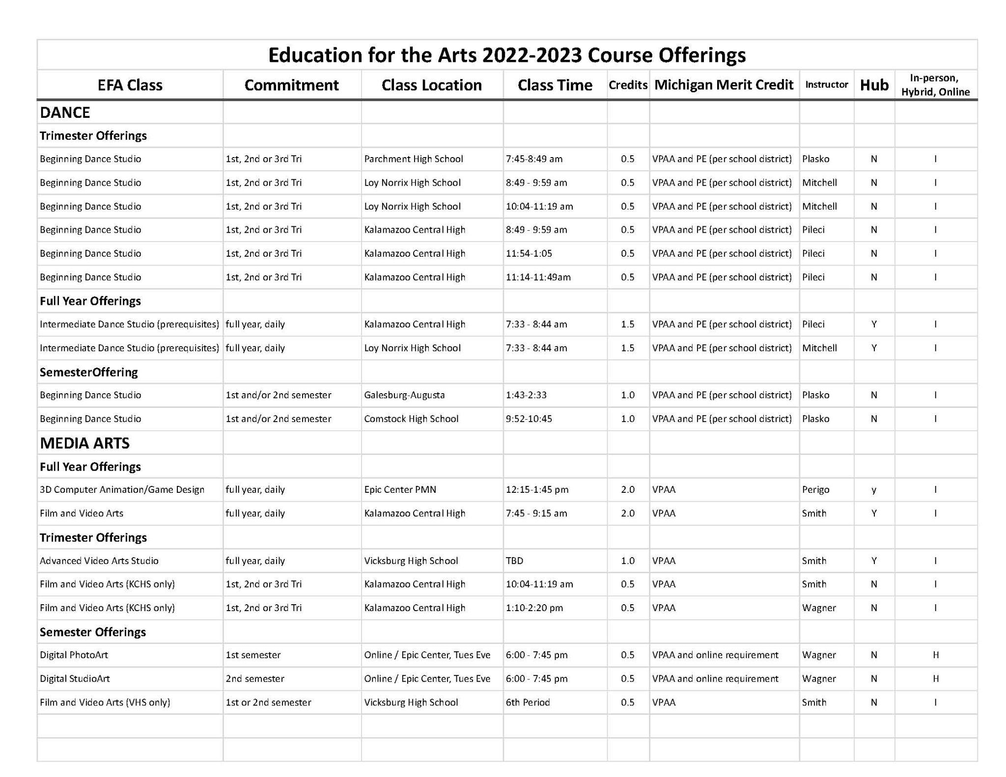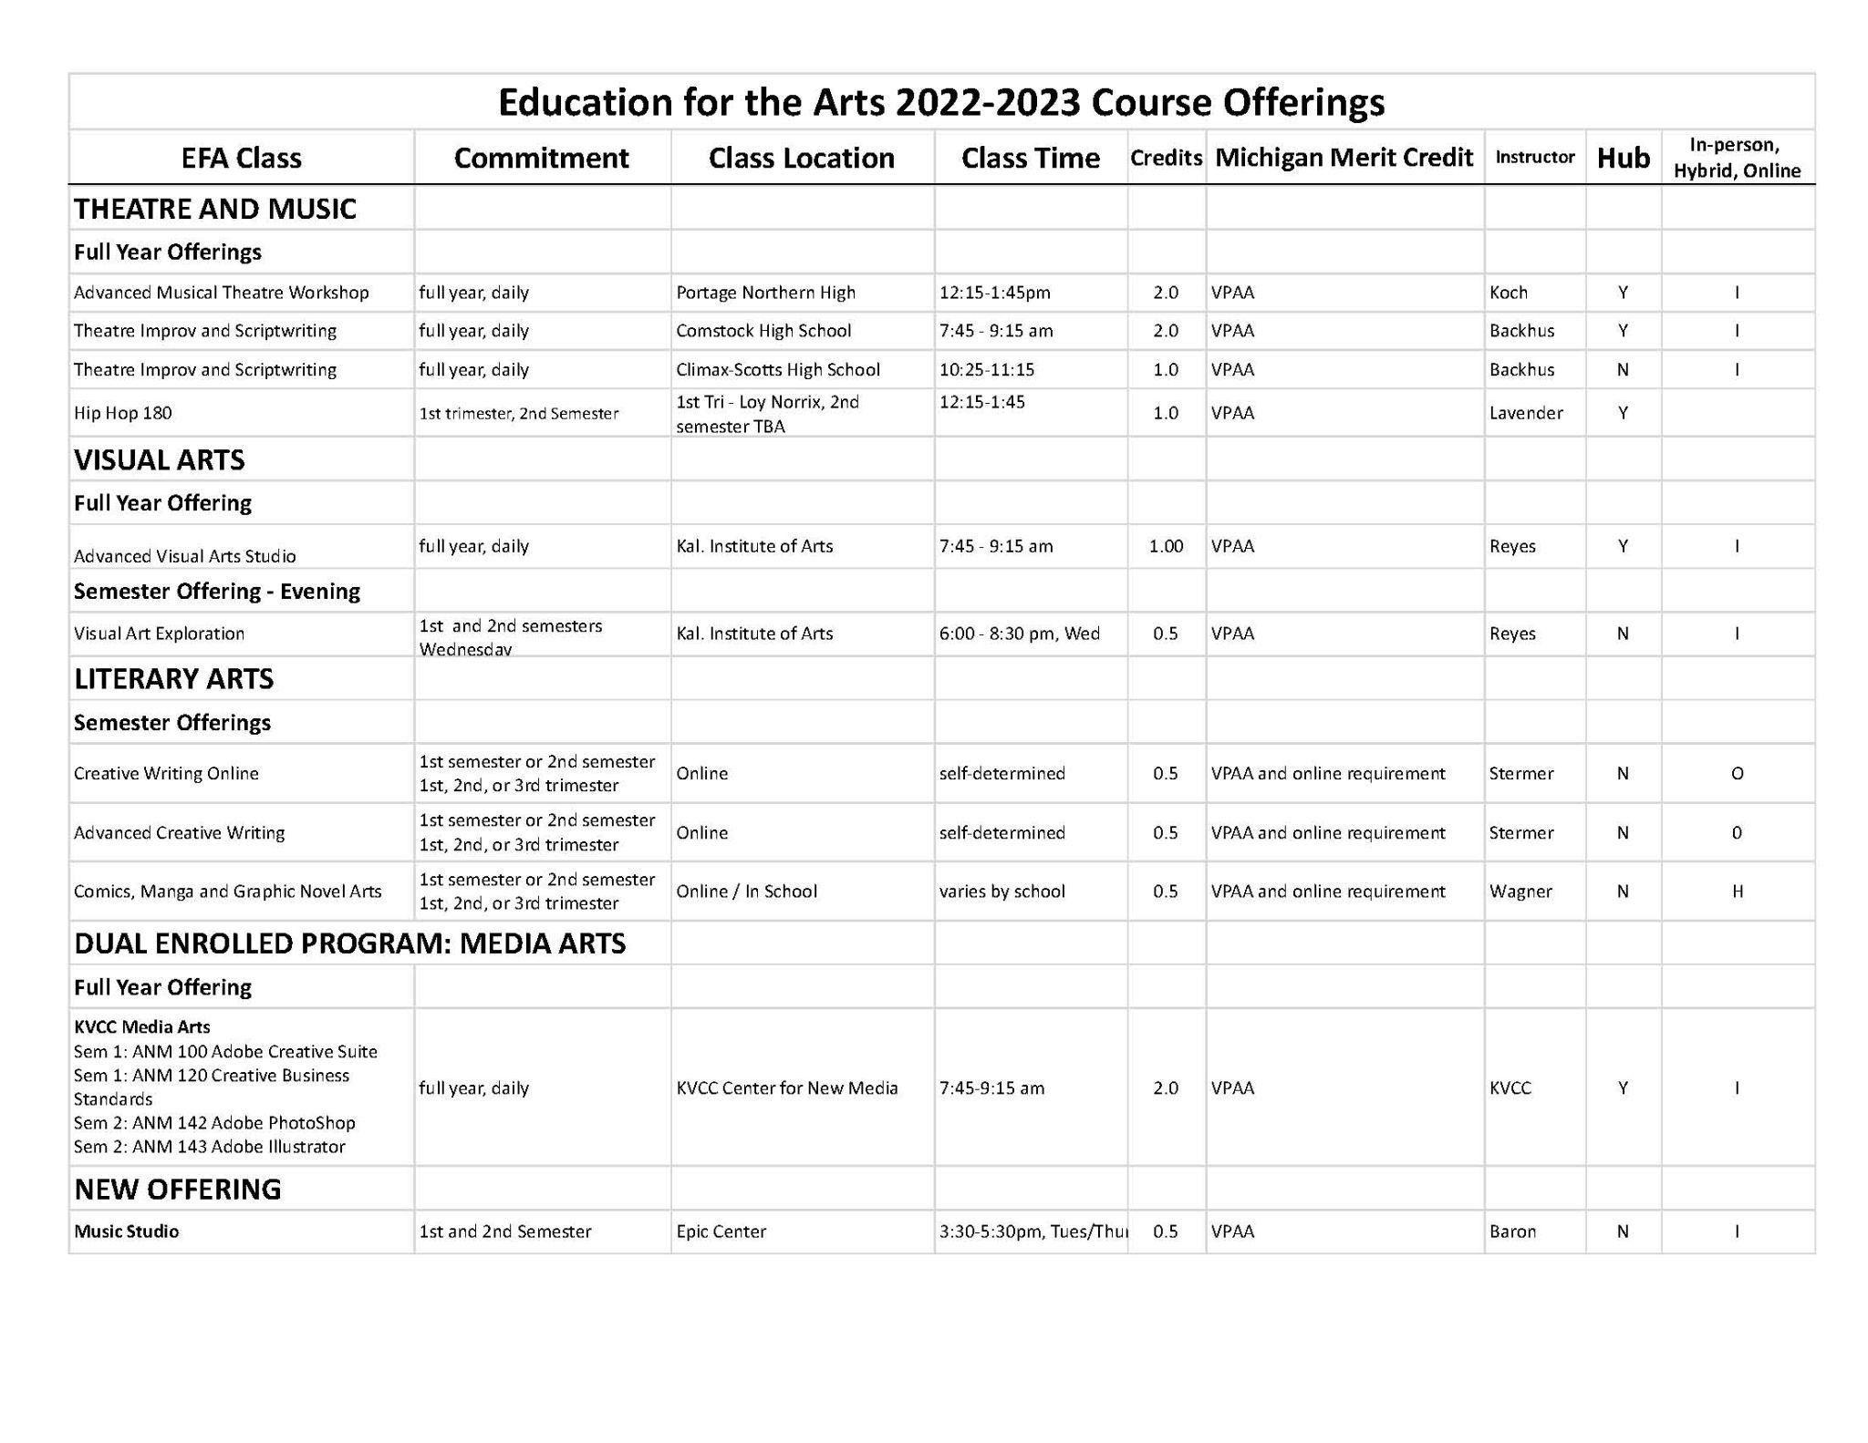

EDUCATION FOR THE ARTS
2022-2023 COURSE DESCRIPTIONS

DANCE

Beginning Dance Studio
Comstock / Loy Norrix / Kalamazoo Central / Parchment
Learn the basic elements and discipline of formal dance technique, exploring classical modern dance, ballet, jazz, hip hop, and cultural dance styles. Exploration of dance-related subjects will include movement improvisation, composition, and dance history. Students gain performance skills, learn how to choreograph their own dances and are required to participate in EFA dance concert at end of each term. They will have the opportunity to take field trips to see live dance concerts and attend master classes. Students will work with professional dance educators and guest artists.

Intermediate Dance Studio
Kalamazoo Central / Loy Norrix
Intermediate Dance is for students who have completed a beginning EFA class, or have previous dance/movement experience, and are committed to a full year of dance instruction. Students will further their training through in-depth instruction and structured small group student exploration in formal dance technique, classical modern dance, ballet, jazz, hip hop, and cultural dance styles. Exploration of dance-related subjects will include movement improvisation, composition, and dance history. Students will gain performance, composition, and choreographic skills, develop observation, analysis, critical thinking, and reflection skills. Students will prepare and produce a dance presentation each trimester. The class will take field trips to professional dance concerts and work with master guest artists.

LITERARY ARTS

Creative Writing Online
Web based
Through the study of written works in various forms and the regular practice of writing, students will achieve a better understanding of the creative writing process. Additionally, students will collaborate on a few projects, and will read and critique one another’s work through small group workshops (held through discussion forums). Students will turn in four major creative writing assignments, regular creative writing exercises, three short reflections, a recording of student performing one of their assignments, and an online portfolio.

Advanced Creative Writing
Web based
This class is open to motivated writers who have successfully completed the Creative Writing Online class. Students will submit an individualized writing project to the instructor in any creative writing genre. Instructor will develop with students a relevant research plan and writing / revision calendar. Students will receive feedback from instructor and peer student writers. Final writing product will be shared in an on-line portfolio and submitted to student writing festivals.
Comics, Manga and Graphic Novel Arts
Web based and at High School
Learn to write and produce compelling, artistic and inventive comics or manga, and Graphic Novels. Research the history of comics, study the elements of story, plot, and character development, and the productive use of imagery, layout, and composition. Work individually and collaboratively on projects and develop projects through manipulation and editing of found media and open source graphics.

MEDIA ARTS

Film and Video Arts
Kalamazoo Central and Vicksburg High Schools
Film & Video Arts introduces students to the creation and study of time-based media in video and film. They work with the latest digital technology in creating a variety of works that help them mold and define their own personal visual style for innovative, artistic communication.

Advanced Video Arts Studio
Vicksburg High School
AVAS is a project-based video class for 9-12 grade students who have already taken at least one semester of a video or TV production class. The class will concentrate on individual student films that will be used for portfolio work and entered into video competitions. Students will learn about lighting, sound, directing and advanced filming and editing techniques.

3D Computer Animation and Game Design
Epic Center Public Media Network
Introduction to the technical and creative fundamentals of 3D Animation software. Students will learn core concepts such as modeling, mapping, storyboard/scripting, and rendering. Students will create original characters and environment designs, animate characters in a game landscape, and design storyboards using gaming logic and strategies.

KVCC Media Arts
Kalamazoo Valley Community College – Center for New Media - EFA/KVCC Dual Enrolled Program
Fall Semester: ANM 120: Creative Business Standards, MF and ANM 100 Adobe Creative Suite
Winter Semester: ANM 143 Adobe Illustrator, MF and ANM 142 Adobe Photoshop, TWR
Create artworks using computers as tools and learn how art communicates emotions and ideas. Projects include digital photograph manipulation, art for the Internet, stereo 3D images, digital painting, and combining traditional media with new technologies.

Digital StudioArt
Web based and Epic Center Public Media Network
This class will introduce the basics of drawing and painting using digital means, in the process also giving them an introduction to the basics of digital imaging using Adobe Photoshop and Illustrator. The course is built around the core elements of visual art, such as line, shape, value, and color with an additional emphasis on learning and using the tools of imaging software.

Digital PhotoArt
Web based and Epic Center Public Media Network
This class will introduce, enhance and refine students’ ability to express themselves with the aid of digital cameras. Students will learn proper photographic technique, computer enhancement of photos, printing and professional presentation techniques. Students will have many assignments ranging from core photography fundamentals to immersive pieces of personal expression. They will leave class with the beginnings of a portfolio and knowledge to continue and expand their work in the future.

VISUAL ARTS

Visual Arts Exploration: Wednesday Evenings. One Semester. Kalamazoo Institute of Arts
Explore creating sculpture, photography, jewelry, painting and more at the Kalamazoo Institute of Arts. Work alongside practicing professional artists as they share their knowledge and expertise in art making.
Advanced Visual Arts Studio: School Day. Full-year. Kalamazoo Institute of Arts
Deepen your creativity and visual arts skills at the Kalamazoo Institute of Arts. Take advantage of the professional facilities, equipment, and master guest artists. This studio class offers advanced study in sculpture, oil painting, jewelry, photography, welding, printmaking, ceramics, and more. Develop a Visual Arts Portfolio and learn presentation skills to apply for college scholarships and student art shows.

THEATRE and PERFORMING ARTS

Advanced Musical Theatre
Portage Northern High School
Using a workshop approach, students will experience an in-depth study of musical theatre to enhance their appreciation of the genre and improve their practical performance skills in acting, vocal and dance performance. Mentored by theatre, vocal and dance educators and guest artists, students will explore, perform, and critique various aspects of musical theatre from the past to the present. Emphasis will be placed on creative and innovative approaches to performing works.

Theatre Improv and Scriptwriting
Comstock and Climax-Scotts High Schools
Through in-depth study and practice students will learn the basics of improvisation, writing, directing and acting for the stage, as well as integrating image and music into their own theatrical performances. Students work with practicing artists exploring different forms of theatre, from classical to contemporary. These experiences will inform the development of each student’s distinct writing style. Students will participate in a minimum of two class performances and visit area theatres to experience a variety of stage productions.

Hip Hop 180
Location TBD
Activate your voice and amplify your vision through the power of performance rap/poetry, music, and movement. Dig into the history of Hip Hop culture and social justice leadership to build skills, decipher contexts, and determine truths. Then merge your artistic and activist knowledge and techniques to enact meaningful, positive social change in y(our) community.
Music Studio: NEW CLASS Tues/Thurs Afternoon. One Semester. Epic Center Learn to create and record your own music from the first beat to the last chord. Students will develop deep listening skills to break down the elements of music composition: rhythm, tempo, melody, harmonics, and lyrics. With these musical tools, students will compose new music, mash-up music genres, and re-envision and create cover songs. Students will learn the basic techniques of studio recording and post-production.

Kalamazoo Countywide Career and Technical Education Courses for Merit Academic Credit 2022-23
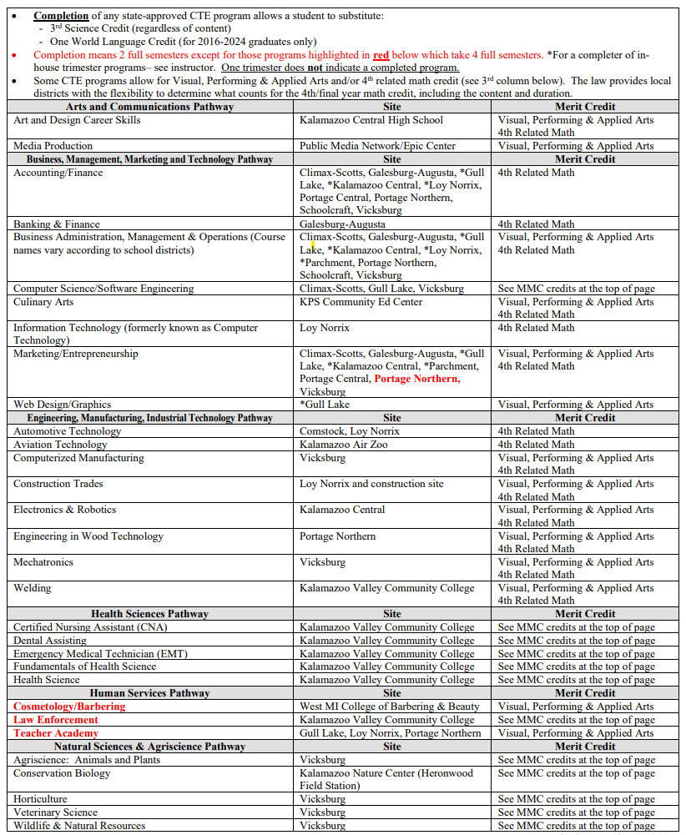

Career Technical Education
2022-2023 Curricular Offerings/Course Schedule

ARTS AND COMMUNICATION PATHWAY

CREDIT | COURSE  TITLE | LOCATION | DESCRIPTION
2 | Art & Design Career Skills | Kalamazoo Central HS | This course allows students to explore and perfect skills in various art media, use professional quality art materials, work on Macintosh computers and tablets, and learn the Adobe Creative Suite programs including Photoshop, Illustrator and InDesign. Students will attend trips to art exhibitions and performances, design firms and school of art tours. Students will research various post-secondary programs and careers in commercial art and design, which may include animation, digital art, fashion design, graphic design, interior design, photography, printmaking, visual art and more. Designers working in the industry, as well as representatives from post-secondary institutions will visit the classroom to consult with students. Students will create a resume, assemble a professional portfolio and attend a portfolio review in preparation for college admissions and internships.  *Potential for articulated credits with Baker College, Davenport University, Ferris State University, and Kalamazoo Valley Community College  *4th Related Math and Visual, Performing and Applied Arts Credit.  *See your counselor for possible 3rd Science and/or 2nd World Language Credit *This is an Early/Middle College eligible program
2 | Media Production | Kalamazoo Public Media Network at the Epic Center. | This course is ideal for students who want to learn how to create media content using visual, audio, graphic and storytelling production techniques for internet, podcasting, television, film, and radio. Students will gain work experience in such skills as video editing, audio production, video composition, graphic composition, effective communication and more. This class provides students with the opportunity to enter local and national competitions as well as airing student work on Public Media Network stations.  *Potential for articulated credits with Davenport University and Kalamazoo Valley Community College  *2nd World Language Credit  *3rd Science Credit  *Visual Performing & Applied Arts Credit

ARTS AND COMMUNICATION PATHWAY COURSES AT VHS

Art I Creative Writing Yearbook 3-D Sculpture
Photography BMA I 2-D Drawing Debate

BUSINESS, MANAGEMENT, MARKETING AND TECHNOLOGY PATHWAY

CREDIT | COURSE  TITLE | LOCATION | DESCRIPTION
1 | Accounting I, II, III | Vicksburg HS | See course descriptions
2 | AP Computer Science | Vicksburg HS | See course descriptions
2 | Banking and Finance | Galesburg-Augusta HS | This course provides students with a background in customer service, personal finance, budgeting, investment planning, and business financial management. Students gain exposure to the various career options in the field. They learn how the financial decisions that they make today affect their future.  *Potential for articulated credits with Davenport University  *4th Related Math Credit  *See your counselor for possible 3rd Science and/or 2nd World Language Credit
2 | Culinary Arts | Kalamazoo Public Schools Community Education Center | This program provides students with the opportunity to learn about the restaurant and food service industry. The curriculum, ProStart, was created by the National Restaurant Association and complies with all State standards. Students learn basic food preparation and explore different fields of the culinary trade. Instruction and learning activities are provided in a food lab using hands-on experiences. The curriculum includes, but is not limited to, front-of-the-house duties, as well as back-of-the-house duties. Additional activities provide instruction in a wide range of topics from management and employability skills to catering. Students participate in culinary competitions and acquire industry recognized certifications needed to succeed in the industry and post-secondary education.  *Potential for articulated credits with Baker College, Davenport University, Ferris State University and Kalamazoo Valley Community College  *4th Related Math Credit  *See your counselor for possible 3rd Science and/or 2nd World Language Credit  * This is an Early/Middle College eligible program
2 | Information Technology I | Loy Norrix HS | Students enrolled in this program will be exposed to numerous Information Technology specialty areas and choose one of the following career paths to focus on for the year. PC Technician: This path provides a thorough overview of what it means to work as a Tier 1 technician for an I.T. department. Students will learn about hardware, Windows and Linux operating systems, printers, scripting, networking, security and troubleshooting. Eligible certifications include CompTIA’s IT Fundamentals and A+, Microsoft’s Networking, Operating Systems, and Security Fundamentals; and TestOut’s IT Fundamentals and PC Pro. Cisco Networking: Students in this path will experience a comprehensive introduction to the networking field and in-depth exposure to fundamental networking, LAN switching, wireless LANs, basic routing, Cybersecurity, WAN concepts, VPNs, QoS, virtualization, and network automation. Threaded throughout the course are security concepts and skills including threat mitigation through LAN security, ACLs, and IPsec. Eligible certifications include Cisco’s CCNA and CompTIA’s Network+.  *Potential for articulated credits with Baker College, Davenport University, Kalamazoo Valley Community College  *2nd World Language Credit  *3rd Science Credit  *4th Related Math Credit  This is an Early/Middle College eligible program.
2 | Information Technology II | Loy Norrix HS | Students returning for a second year of Information Technology will take a deeper dive into opportunities, work semi-independently and focus on one or more of the following areas of IT: cybersecurity, servers, Linux, or cloud.  Cybersecurity: Initial topics will include an introduction/refresher into Python coding, Linux, and IoT devices. Students will then dive into the world of ethical hacking. Servers: The course is designed to prove mastery of the skills required to administer Windows Server, including installation and implementation of storage solutions, Hyper-V, and Windows containers; networking with DNS, DHCP, IP address management, and advanced infrastructure; and administration of Active Directory Domain Services, group policy, Nano Server, and more. Linux: Linux is everything from cars and smartphones to servers and supercomputers, as a vast number of enterprises use Linux in cloud, cybersecurity, mobile and web administration applications. Cloud: This course is conditional upon current applications with Microsoft and Amazon partnerships. Students will learn what the cloud is and how it works, differentiate between cloud computing and deployment models, and describe the basic global infrastructure of the cloud.  *Potential for articulated credits with Baker College, Davenport University, Kalamazoo Valley Community College  *2nd World Language Credit  *3rd Science Credit  *4th Related Math Credit  This is an Early/Middle College eligible program.
1 | Marketing | Vicksburg HS | See course descriptions

BUSINESS, MANAGEMENT, MARKETING AND TECHNOLOGY PATHWAY COURSES AT VHS
Accounting Introduction to Computer / AP Computer Science Principles
Marketing

ENGINEERING/MANUFACTURING AND INDUSTRIAL TECHNOLOGY PATHWAY

CREDIT | COURSE  TITLE | LOCATION | DESCRIPTION
2 | Automotive Technology | Loy Norrix HS | This National Automotive Technician Education Foundation (NATEF) certified program covers these areas of automotive service: engine, brakes, electrical & electrical systems, steering & suspension, auto & manual transmissions and air conditioning. Students may have the opportunity to become state certified, as well as to earn credit towards completion of an associate degree or other post-secondary training. Students may take this course for two years.  *Potential for articulated credits with Baker College, Kalamazoo Valley Community College and University of Northwestern Ohio  *4th Related Math Credit  *Possible 3rd Science and/or 2nd World Language Credit  * This is an Early/Middle College eligible program.
2 | Aviation Technology | Kalamazoo Air Zoo | Students in this course are dually enrolled and have the opportunity to earn college credit through Kellogg Community College (KCC) in addition to high school credit. The KCC aviation coursework is part of a bridge agreement with Western Michigan University, College of Aviation and is delivered as on-line courses. Instructional Support provided by CTE to ensure student success at the college level. This program is designed to introduce students to every aspect of the aviation industry and is intended for students with an interest in pursuing any career related to aviation. Students will develop a broad knowledge base in subject areas ranging from evolution of airplanes and commercial aviation, flight operations, weather, airspace, navigation, regulations, and aircraft systems. Students have the opportunity to interact with industry experts and visit leaders in the field of aviation for career exploration. The program will feature many hands-on labs.  Students may take this course for two years.  *Potential for articulated credits with Baker College and Northwestern Michigan College  *Dual Enrollment at Kellogg Community College – with bridge agreement to WMU-College of Aviation  *Possible 3rd Science and/or 2nd World Language Credit  *4th Related Math Credit
2-2 hours  1-1 hour | Computerized Manufacturing I, II | Vicksburg HS | See course descriptions  This course may be taken for 2 years.
2 | Construction  Trades | Loy Norrix HS and at construction site | This course exposes students to several aspects of the construction industry including site, layout, carpentry, electrical, masonry, plumbing, heating, plastering, painting, and other construction skill areas. Both male and female students will enjoy the hands-on training experience in remodeling and/or new construction of a home that this course has to offer. Classroom training is also an important component of the class. Students interested in this course should understand basic concepts of measurement and mathematics and be able to work indoors or outdoors. Students may take this course for two years. Taught in connection with Kalamazoo Valley Habitat for Humanity Program.  *Potential for articulated credits with Baker College and Kalamazoo Valley Community College  *Possible 3rd Science and/or 2nd World Language Credit  *4th Related Math and Visual Performing and Applied Arts Credit
2 | Electrical Technology | KVCC | Students in this course are dually enrolled and have the opportunity to earn college credit through Kalamazoo Valley Community College. This course provides instruction and training in the areas of applied electricity, residential wiring and code, and safety and first aid. Students will learn basic electrical theory and practices as well as wiring theory and gain lab experience. Upon successful completion of this course, the student should have the knowledge and ability to wire a residence according to the national electrical code. Throughout the program, students gain valuable practical experience working on residential, commercial, and industrial wiring. Students interested in this class should enjoy working with mathematical formulas and algebraic concepts.  *Dual enrollment at Baker College and Kalamazoo Valley Community College – 7 College Credits  *Possible 3rd Science and/or 2nd World Language Credit  *4th Related Math Credit
2 | Electronics and Robotics | Kalamazoo Central HS | This is an excellent course for students to use their creativity to solve problems and figure out how things work. A hands-on approach will introduce students to concepts and skills in current and emerging technical fields. The course features high-tech equipment and programs in a student-centered classroom. Projects challenge and engage students’ minds to provide a strong foundation that could launch them into engineering or other high-tech careers such as alternative energies, robotics and automated systems, optics, biomedical, and nanotechnology. Students may take this course for two years.  *Potential for articulated credits with Davenport University, Baker College and Kalamazoo Valley Community College.  *Possible 3rd Science and/or 2nd World Language Credit  *4th Related Math and Visual Performing and Applied Arts Credit
2 | Engineering in Wood Technology | Portage Northern HS | Engineering in Wood Technology is a course that covers the rudimentary techniques of woodworking and cabinetmaking in relation to industry. This class provides true differentiated training for the real-world of manufacturing and industry, with student directed studies ranging from areas of programming and operation of CNCs, laser engraving and even 3D printing technologies to rustic woodworking using traditional tools such as Japanese pull saws or hand lathes. This course offers higher-level training in management and student leadership via a complex student-run student-led class structure. Students after leaving this class present skills applicable in all walks of life and will be career or college ready.  *Potential for articulated credits with Michigan Career & Technical Institute  *4th Related Math and Visual Performing and Applied Arts Credit  *Possible 3rd Science and/or 2nd World Language Credit
2 | Heating, Ventilation and Air Conditioning (HVAC) | KVCC | Students in this course are dually enrolled and have the opportunity to earn KVCC college credit in addition to high school credit. This course provides instruction and training in the areas of heating, ventilation, air conditioning and refrigeration as well as the design, installation, and servicing of HVAC/R systems. HVAC prepares students for a technical career upon completion.  *Dual enrollment at Kalamazoo Valley Community College – 12 College Credits.  *Possible 3rd Science and/or 2nd World Language Credit  *4th Related Math Credit
1-1 hour | Mechatronics | Vicksburg HS | See course descriptions
2 | Welding | KVCC | Students in this course are dual enrolled and have the opportunity to earn college credit from Kalamazoo Valley Community College in addition to high school credit. Students must follow all requirements of a dual-enrolled program. Students learn to weld with the most advanced welding processes used today. Content includes the basic safe operation of the ox-fuel welding, cutting, and brazing systems. Students also receive training in the basic electric arc welding processes, SMAW (arc), GMAW (mig), and equipment setup, selection and operation. Blueprint reading for welders, welding symbols and basic welder’s trade math are included to prepare the student for employment in the welding trade.  *Potential for articulated credits with Baker College and Ferris State University  *Dual enrollment at Kalamazoo Valley Community College – 6 College Credits  *Possible 3rd Science and/or 2nd World Language Credit  *4th Related Math and Visual Performing and Applied Arts Credit  *This is an Early/Middle College eligible program.

ENGINEERING/MANUFACTURING AND INDUSTRIAL TECHNOLOGY PATHWAY COURSES AT VHS

Computerized Manufacturing I, II Mechatronics

HEALTH SCIENCES PATHWAY

CREDIT | COURSE TITLE | LOCATION | DESCRIPTION
1.5 | Certified Nursing Assistant (CNA) | KVCC Groves | Learn to care for patients in a caring and compassionate manner. Students first learn patient care techniques in a simulated lab environment, followed by a clinical rotation at a long-term care facility. This program is designed to introduce students to the fundamentals of health care, core skills, and health care professional behavior. Upon completion of the program, students are offered study and practice sessions to prepare for the state of Michigan competency exam. Once prepared, students will take the Michigan Nurse Aide Competency Evaluation which includes skills and knowledge tests.  *Articulation to be determined  *2nd World Language Credit  *3rd Science Credit
2 | Dental Assisting | KVCC and local dental offices | Students choosing this program will be dually enrolled through Kalamazoo Valley Community College (KVCC) and can earn both high school and college credit for the course. Students will need to meet the college’s entrance expectations, as well as having their schedule open to extended class times and the college’s calendar. Enrollment in the EFE Dental Assisting program begins a preferred relationship with the KVCC Dental Hygiene program that could later impact a student’s acceptance into the KVCC program.  The course prepares students to become dental assistants. Students will learn the fundamental knowledge and skills of dental anatomy, physiology, terminology, dental materials, chairside assisting, sterilization, radiology, laboratory and clinical procedures. Second semester incorporates an internship held in KVCC’s Dental clinic and local dental offices. *Dual enrollment at Kalamazoo Valley Community College - 10 college credits *Possible 3rd Science and/or 2nd World Language Credit
2 | Emergency Medical Technician | KVCC | Students in this class are dually enrolled and have the opportunity to earn both high school and college credit. Students will need to meet the college's entrance expectations, as well as having their schedule open to extended class times and the college's calendar. EMT consists of a sequence of KVCC courses. Each course is a prerequisite to the next course. Basic EMT provides students with instruction in basic emergency medical technology. The EMT course is a study of the topics and skills necessary to make lifesaving interventions and stabilize patients during transport to a medical facility. The course involves lecture and practical skills labs and introduces the clinical component of EMT education, the minimum level of training required for work on a transporting ambulance. Second semester students will complete clinical hours with a local ambulance service and healthcare agencies. Upon successful completion of this course, students are eligible for Michigan Department of Health and Human Services licensing as a Medical First Responder (MFR). In addition, students may also be eligible to sit for the national Registry Basic EMT licensing examination. *Dual enrollment at Kalamazoo Valley Community College – 10 college credits *Possible 3rd Science and/or 2nd World Language Credit This is an Early/Middle College eligible program.
3 | Health Science | KVCC | This course introduces the student to health care, with an emphasis on core skills and knowledge applicable to many professional health care disciplines. The curriculum integrates anatomy and physiology, medical terminology, and basic care skills through practical applications found in the health care setting. Students will investigate career choices through workplace observations. Students should enjoy working at a fast pace and be considering a healthcare career requiring a minimum of four years of post-secondary education. *Potential for Dual enrollment at Kalamazoo Valley Community College *Potential for articulated credits with Baker College, Davenport University, Ferris State University, and, Kalamazoo Valley Community College *Possible 3rd Science and/or 2nd World Language Credit
3 | Professional Health Science | KVCC and local healthcare partnerships | Professional Health Science provides advanced training and experience in the healthcare field. This course includes internship experiences and enrollment in advanced skill mini courses such as phlebotomy, electrocardiography, patient care assistance and exercise science/sports medicine. Students successfully completing CPR/AED and medical terminology instruction may receive articulated college credit. This second-year course represents the most advanced level of study in the health science program. Students applying to the program must meet specific achievement and performance prerequisites within either Health Science or Fundamentals of Health Science before gaining admission. *Potential for Dual enrollment at Kalamazoo Valley Community College *Potential for articulated credits with Baker College, Davenport University, Ferris State University and Kalamazoo Valley Community College *Possible 3rd Science and/or 2nd World Language Credit
HEALTH SCIENCES PATHWAY COURSES AT VHS
Family Living Nutrition Psychology AP Psychology

HUMAN SERVICES PATHWAY

CREDIT | COURSE  TITLE | LOCATION | DESCRIPTION
3 | Cosmetology or Barbering | West Michigan College of Barbering and Beauty | This is a state-certified program of instruction designed to prepare students to become a licensed professional cosmetologist or barber. Michigan’s cosmetology course includes 1,500 clock hours (barbering includes 2,000) of mandatory attendance. In order to complete this requirement, students must be committed to attending the program during an extended day all through their junior and senior years and the summer that falls between. Students not meeting this requirement during their EFE enrollment will need to complete the program at their own expense. Upon successful completion of this prerequisite, students will be prepared to take their Michigan State Board Exam.  *Cosmetology Licensure available  *Potential for articulated credits with Ferris State University and Davenport University  *Possible 3rd Science and/or 2nd World Language Credit  *Visual Performing & Applied Arts Credit
2 | Law Enforcement I | KVCC | This unique program features a former Kalamazoo Public Safety officer as the instructor and also includes numerous Public Safety Professionals as guest speakers from throughout the field including local, state, county and federal officials.  Law Enforcement I introduces students to the many different careers available within the field. The program emphasizes the knowledge, skills, and ethics needed to be a successful police/fire academy recruit. Areas of study include criminal law, patrol procedures, fire ground operations, first aid/CPR/AED certifications, defensive tactics, crime scene investigation, and oral & written communication skills. The program follows MCOLES and police academy standards, as well as current college curriculum.  *Potential for articulated credits with Baker College, Davenport University, and Kalamazoo Valley Community College  *Possible 3rd Science and/or 2nd World Language Credit  *Taught by a Kalamazoo Department of Public Safety Law Enforcement Officer at KVCC
2 | Law Enforcement II | KVCC and local internship sites | Law Enforcement II deepens students’ understanding of criminal procedures and improves their written and oral communication skills. Eligible students will intern with local public safety agencies during second semester, where they will apply the knowledge, skills, and ethics learned to real world situations.  *Potential for articulated credits with Baker College, Davenport University, and Kalamazoo Valley Community College  *Possible 3rd Science and/or 2nd World Language Credit  *Taught by a Kalamazoo Department of Public Safety Law Enforcement Officer at KVCC
2 | Teacher Academy | Portage Northern and local classrooms | The Teacher Academy is designed to introduce students to various careers in the Education and Training Career Cluster. Students will gain yearlong hands-on experience working in a pre-kindergarten, elementary or middle school classroom four days per week. In addition, students will learn the necessary background knowledge of child development and principles of effective teaching through a hybrid program of learning which includes weekly online learning, class meetings, extended research projects, field trips and interviews. Students work under the joint direction of an EFE instructor and a master teacher in their area of interest as they learn to plan and direct instruction for individuals and groups, develop materials, assist with record keeping and complete other responsibilities of teachers and other school personnel. Discover the rewards and joys of teaching!  *Potential for articulated credits with Central Michigan University, Baker College, Ferris State University, Saginaw Valley State University, and Western Michigan University.  *Visual Performing & Applied Arts Credit  *Possible 3rd Science and/or 2nd World Language Credit  *Hybrid class taught online, one day a week at area high schools and four days a week at area prekindergarten, elementary and middle schools

HUMAN SERVICES PATHWAY COURSES AT VHS

Psychology Nutrition Family Living

NATURAL RESOURCES AND AGRISCIENCE PATHWAY

CREDIT | COURSE  TITLE | LOCATION | DESCRIPTION
2 | Agriscience | Vicksburg HS | Interested in growing plants? Want to know about and do more with animals? Interested in natural resources? This is a year-long, hands-on course that allows you to do it all. One semester is spent learning about plants: how to grow them, how they work, and how they feed the world. Students learn about plants and their relationship and importance to people. Students also study plant classification, cell structure, plant parts and functions, plant processes, plant nutrition and soils. The other semester is based upon animals--all kinds of animals. Students learn about basic biology, behavior, care and handling of a broad range of species. Students study domestic livestock production, animal health and nutrition, animal genetics and reproduction, and animal anatomy and physiology. Students study the selection, breeding, feeding, care, and marketing of animals, as well as the role of pets and other animals and their interactions with humans.  *Potential for articulated credits with Davenport University  *Possible 3rd Science and/or 2nd World Language Credit
2 | Conservation Biology | Heronwood Field Station | This program introduces students to the exciting careers in Natural Resource Conservation and Wildlife Biology. This laboratory/field based course involves hands-on learning of ecological science, animal and plants studies (i.e. behavior, identification), job shadowing and field trips. This course will have special emphasis on skills and technology used in this profession. Students will have direct contact with natural resource conservationists and wildlife biologists in this field of study. They will attain the skills necessary to obtain employment in various careers Natural Resource Conservation and Wildlife Biology.  *Potential for articulated credits with Davenport University  *Possible 3rd Science and/or 2nd World Language Credit
2 | Veterinary Science | Vicksburg HS | During the first semester, students will focus on anatomy, medical terminology, hematology, animal breeds, animal health and care, restraint and handling, veterinary lab procedures and parasitology. The second semester will combine continued classroom instruction on specific skills with field work in area veterinary clinics. This program will introduce students to and help prepare students for various jobs in the field of veterinary medicine.  *Potential for articulated credits with Davenport University

NATURAL RESOURCES AND AGRISCIENCE PATHWAY COURSES AT VHS

Physics Chemistry Horticulture
Wildlife/Natural Resources Agriscience Anatomy
Physiology AP Biology AP Chemistry
AP Physics Veterinary Science

WORK-BASED LEARNING

CTE Work-Based Learning (formerly known as Co-op or Cooperative Education)
An experience for 11th and 12th grade students who have successfully completed a trimester or semester of a CTE course. Students can earn credit and receive a grade while they learn through a paid, related work experience.
Participating students shall:
- Be employed in a coordinator-approved work setting,
- Work at least 10-15 hours per week in class-related, legal employment,
- Receive release time from school, school credit, on-the-job training, and pay, and
- Be evaluated every grading period by his/her employer.

Prerequisite: CTE related class. Successful completion of one trimester or semester of an CTE course and continued concurrent enrollment in CTE.
NOTE: Students are not to be officially enrolled in CTE Work-Based Learning until the Work-Based Learning Coordinator has approved their application and job site. Additionally, employment is subject to forces outside of the control of the school district, therefore, employment cannot be guaranteed. For these reasons, it is recommended that students maintain a full schedule of classes until all conditions are met.

